PROJECT TITLE HERE

PROJECT REPORT
Submitted by

Group Member1 Name (Reg no.)
Group Member2 Name (Reg no.)
Group Member3 Name (Reg no.)

Prepared For

DATABASE SYSTEMS (BCSE302P) -Lab PROJECT

Submitted To

Dr. Anand Bihari

School of Computer Science and Engineering



Abstract

Table of Contents
Contents
1. Introduction 4
2. Project SCOPE 4
3. Key Contacts and Stakeholders 4
4. Project Resource Requirements 4
4.1 Software Resource Requirements 4
5. ER Diagram 5
6. Tables and Constraints 6
7. SQL Implementation 7
8. Advanced SQL Implementation 7
10. Work break down 8
11. REVIEW EVALUATION 9

Introduction
Every educational institution focuses on reduction of malpractices during examinations and there by establish good standards that contribute towards optimized evaluation processes for their students. As a result the institution can gain credibility in the eyes of the industry by reducing the gap in terms of identifying the right candidate for the various opportunities available. The Malpractice Management System is one such system that focuses on effective utilization of resources towards malpractice management thereby catering towards evaluation process optimization for students and faculty.

Project SCOPE

Malpractice Management System aims at automation of the following processes

- Malpractice Registration by faculty members
- Assignment and communication of enquiry committee members
- Status tracking of Reported malpractices by students
- Auto email Generation about the reported malpractice to the proctors and parents of the concerned students
- Report Generation on the malpractices reported for measuring the effectiveness of the examination conduction process.

Key Contacts and Stakeholders
Name | Registration Number | Phone Number/Email
Team Member 1 | 111111111 | 9962545500
Team Member 2 | 222222222 | 8878878777

Project Resource Requirements

Software Resource Requirements
- Windows XP (Service Pack3)
- mysql
- HTML 5
- JavaScript
- PHP5.5
- Apache Web Server
- Rational Rose Enterprise Edition
- 2-Plan
- ArgoUML

ER Diagram
Updated ER diagram required here
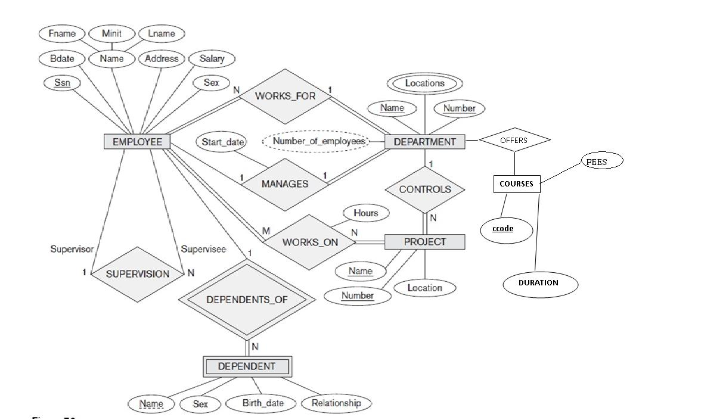

Tables and Constraints

Include a description of each table and explain the relationships between the tables. Specify the normal form satisfied by each table. Also, include screenshots of the table creation statements. Update the table 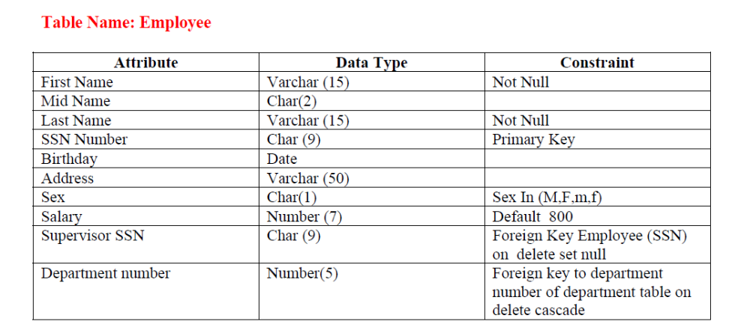

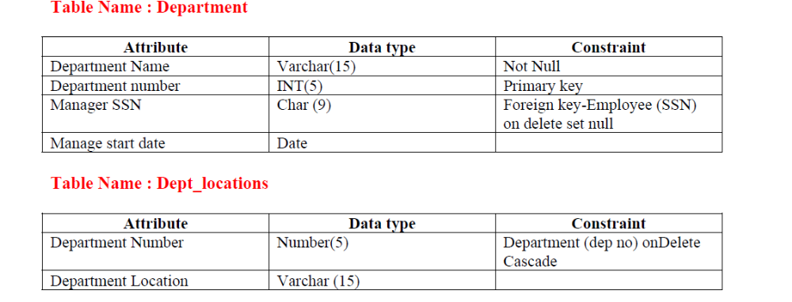

SQL Implementation

They should demonstrate actual implementation, not just design. Include screenshot of each query with at least one ouput.

Category | Required coverage | Min queries
A. Basic | SELECT, WHERE, ORDER BY, DISTINCT, BETWEEN, IN, LIKE, IS NULL | 6
B. Aggregate | COUNT, SUM, AVG, MIN, MAX, GROUP BY, HAVING (must contrast WHERE vs HAVING in one query) | 5
C. Joins | INNER, LEFT, RIGHT, FULL OUTER (or emulation), SELF, CROSS (meaningful use) | 6
D. Subqueries | Scalar, single-row, multi-row (IN/ANY/ALL), correlated, EXISTS, NOT EXISTS, NOT IN (with a note on the NULL pitfall) | 6
E. Set operations | UNION, UNION ALL, INTERSECT, EXCEPT/MINUS (or equivalents) | 4
F. Advanced functions | CASE, COALESCE, NULLIF, date/time, string, numeric functions | 6
G. Window/analytic (recommended for higher band) | RANK, ROW_NUMBER, running total, LAG/LEAD | 2

Advanced SQL Implementation
- Complex Business Queries (minimum 10)
Each must involve ≥ 3 tables or a nested/analytic construct. Use this template per query:
Field | Content
ID | CQ-01
Business question | Plain-language question a manager would ask
SQL | Formatted query
Expected output | Predicted result before execution (hand-reasoned from data)
Actual output screenshot
Explanation | Join logic, filter logic, why this result is correct

- Views (2–3 minimum)
Field | Content
Purpose
CREATE VIEW statement | At least one view joining ≥ 3 tables; at least one aggregated view; one security/row-restricting view
Query using the view
Screenshot
Why useful | Abstraction, security, simplification; state whether the view is updatable and why/why not
- Stored Procedures (at least 2)
- User-Defined Functions (at least 2)
- Triggers (at least 2)
- Cursor (at least 2)
- SQL Security Implementation
Task | Evidence
Create ≥ 3 users/roles | CREATE USER/ROLE script
GRANT privileges per role matrix | Script + SHOW GRANTS / \dp output
REVOKE demonstration | Before/after
Least privilege proof | Login as restricted user → attempt forbidden operation → show error screenshot
Secure exposure | Views/procedures as the only access path for restricted roles

- Review 2 Requirements (checklist)

# | Mandatory component | Evidence
1 | CREATE TABLE scripts + all constraints | 01_ddl.sql runs cleanly
2 | INSERT, UPDATE, DELETE | 02_dml.sql, row-count table
3 | Basic, aggregate, join, subquery, set-operation queries | ≥ 20 queries at this stage
4 | Views | ≥ 2
5 | Transactions (COMMIT/ROLLBACK/SAVEPOINT) | Demonstration script
6 | Procedures/functions | ≥ 1 each working
7 | Triggers | ≥ 1 working
8 | Indexes + one EXPLAIN comparison
9 | Execution screenshots | With SQL
10 | Design changes since Review 1 | Change log with reasons

Work break down
Team Member Registration Number | Name | Work Assigned
1111111 | Member 1 | Functionality 3a,3b
2222222 | Member 2 | Functionality 3c,3d

REVIEW EVALUATION
COMPONENT | MARKS | MEMBER 1 | MEMBER 2 | MEMBER 3
TOTAL | 10 MARKS

